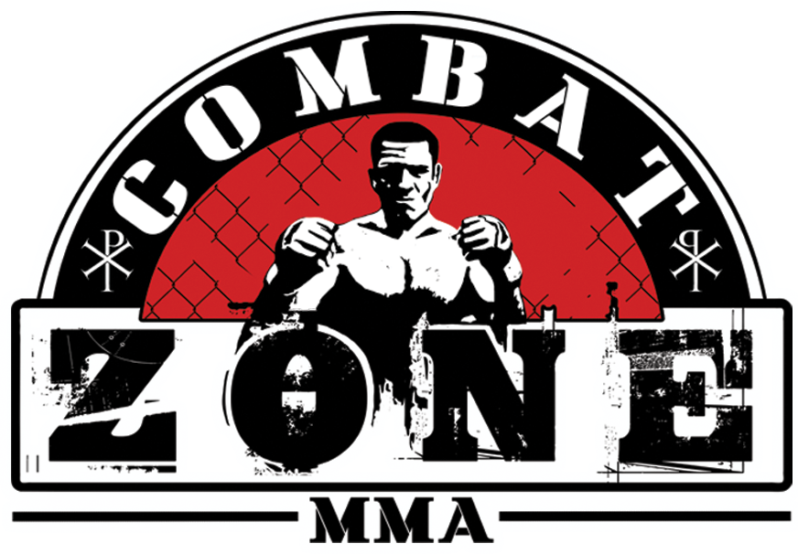

KICKBOXING RULES & REGULATIONS

Professional Rules

-Each match is three rounds in duration, with each round lasting three minutes. Title fights are five rounds in duration, with each round lasting three minutes.

-The match can end by Knockout, Technical Knockout, Decision, Disqualification or No contest. A “No Contest” results from a fighter being unable to continue due to an inadvertent foul, etc.

-The referee, ring doctor and NHBWC all have full authority to stop the fight.

-The fight is scored by three judges on a ten-point must system (The winner of each round receives ten points, and the loser receives nine or less.

-If a fighter scores a knockdown in a round, the round is scored as an 8/10 round in favor of the fighter that delivered the knockdown.

-The three-knockdown rule is in effect (three knockdowns in a round results in a technical knockout).

-The mandatory eight count is in effect (the referee must count to at least "eight" on all knockdowns).

-The standing eight count is in effect (the referee has the right to declare a knockdown on a fighter who appears to be in a dangerous condition to continue in the match).

-If a fighter intentionally spits out their mouthpiece, they’re given a warning. If it happens again, they’ll immediately receive a point deduction. If they do it again, they’re disqualified.

-If a fighter turns their back to the opponent not in a striking motion, he will be given a standing eight count. If it happens again, they’re disqualified.

-A fighter can be saved by the bell only in the last round.

-Allowed to sweep a standing opponent (one or more leg on the ground)

-Elbows and Knees to the head are allowed

-When catching a kick, the fighter is allowed to strike more than once as long as it does not exceed one step

-Clinching is allowed while active, as soon as the action stops the fighters will be separated immediately

-Must use shin for sweep attacks, using the back of the leg is considered tripping and will not be allowed.

-All weight classes wear 10oz gloves.

-No shin pads; no headgear

-Weight classes are the same as MMA. Strawweight up to 115lbs, Flyweight 125lbs, Bantamweight 135lbs, Featherweight 145lbs, Lightweight 155lbs, Welterweight 170lbs, Middleweight 185lbs, Light Heavyweight 205lbs, Heavyweight up to 265lbs.

Medical Requirements
No more than 6 months old for the following-
-HIV Negative Status- Must have actual test results showing HIV negative status.
-Hepatitis B & C Tests- Must have actual test results showing Hepatitis B & C negative results.
No more than 12 months old for the following-
-Eye Exam- Must show that eyes have been dilated and specifically state that there is no sign of detached retina.
-Physical Exam- Must have statement by physician that fighter is fit to compete.
-EKG Printout- Must have actual printout showing that fighter is fit to compete.

Fouls

-Using the head to deliver a blow
-Attacking the opponent in the groin
-Delivering wrestling or judo throwing or submission techniques
-Thumbing, choking or biting the opponent
-Punching the opponent in the throat
-Attacking the opponent while he is down or in the process of getting up
-Attacking the opponent after the referee calls a break
-Holding the ropes/cage
-Using offensive language to the referee
-Attacking the back of the head with a punch
-Attempting to cause the opponent to fall out of the ring
-Voluntarily exiting the ring or cage during the course of a match
-Attacking an opponent who turns around and shows his back (if the opponent loses his will to fight)
-Delivering a backspin blow in an unauthorized area
-Charging inside the opponent's arms with the head held low (inducing a head-butt)
-Fighting in a passive manner (without attacking), including continuous holding and clinching
-Taking more than one step while holding the opponents kicking leg
-Lifting the opponent off the ground
-Body locking while driving your head into your opponent in a backward bending motion.
-Not allowed to wear any oil or lotion before/during the fight

A fighter is penalized as follows
-Warning - verbal reprimand by the referee. A repeat of the violation results in a Point Deduction - fighter is deducted a point. A repeat of the violation again will result in a Disqualification.
-A point deduction happens automatically if a fighter commits a foul with malicious intent.

KICKBOXING RULES & REGULATIONS

Amateur Rules

-Each match is three rounds in duration, with each round lasting two minutes. Title fights are five rounds in duration, with each round lasting two minutes.

-The match can end by Knockout, Technical Knockout, Decision, Disqualification or No contest. A “No Contest” results from a fighter being unable to continue due to an inadvertent foul, etc.

-The referee, ring doctor and NHBWC all have full authority to stop the fight.

-The fight is scored by three judges on a ten-point must system (The winner of each round receives ten points, and the loser receives nine or less.

-If a fighter scores a knockdown in a round, the round is scored as an 8/10 round in favor of the fighter that delivered the knockdown.

-The three-knockdown rule is in effect (three knockdowns in a round results in a technical knockout).

-Three knockdowns total in the fight results in a technical knockout.

-The mandatory eight count is in effect (the referee must count to at least "eight" on all knockdowns).

-The standing eight count is in effect (the referee has the right to declare a knockdown on a fighter who appears to be in a dangerous condition to continue in the match).

-If a fighter intentionally spits out their mouthpiece, they’re given a warning. If it happens again, they’ll immediately receive a point deduction. If they do it again, they’re disqualified.

-If a fighter turns their back to the opponent not in a striking motion, he will be given a standing eight count. If it happens again, they’re disqualified.

-A fighter can be saved by the bell only in the last round.

-Allowed to sweep a standing opponent (one or more leg on the ground)

-Elbows and Knees to the head are illegal

-Clinching is allowed while active, as soon as the action stops the fighters will be separated immediately

-When catching a kick, the fighter is allowed to strike more than once as long as it does not exceed one step

-Must use shin for sweep attacks, using the back of the leg is considered tripping and will not be allowed.

-All weights wear 12oz gloves

-All amateurs must wear shin pads.

-Headgear is optional; if one fighter wants to wear them then both fighters must wear them.

-Shin pads and headgear are provided by the promoter and must be approved by NHBWC.

-Weight classes are the same as MMA. Strawweight up to 115lbs, Flyweight 125lbs, Bantamweight 135lbs, Featherweight 145lbs, Lightweight 155lbs, Welterweight 170lbs, Middleweight 185lbs, Light Heavyweight 205lbs, Heavyweight up to 265lbs.

Medical Requirements
No more than 6 months old for the following-
-HIV Negative Status- Must have actual test results showing HIV negative status.
-Hepatitis B & C Tests- Must have actual test results showing Hepatitis B & C negative results.
No more than 12 months old for the following-
-Eye Exam- Must show that eyes have been dilated and specifically state that there is no sign of detached retina.
-Physical Exam- Must have statement by physician that fighter is fit to compete.
-EKG Printout- Must have actual printout showing that fighter is fit to compete.

Fouls

-Using the head to deliver a blow
-Elbows and knees to the head
-Attacking the opponent in the groin
-Delivering wrestling or judo throwing or submission techniques
-Thumbing, choking or biting the opponent
-Punching the opponent in the throat
-Attacking the opponent while he is down or in the process of getting up
-Attacking the opponent after the referee calls a break
-Holding the ropes/cage
-Using offensive language to the referee
-Attacking the back of the head with a punch
-Attempting to cause the opponent to fall out of the ring
-Voluntarily exiting the ring or cage during the course of a match
-Attacking an opponent who turns around and shows his back (if the opponent loses his will to fight)
-Delivering a backspin blow in an unauthorized area
-Charging inside the opponent's arms with the head held low (inducing a head-butt)
-Fighting in a passive manner (without attacking), including continuous holding and clinching
-Taking more than one step while holding the opponents kicking leg
-Lifting the opponent off the ground
-Body locking while driving your head into your opponent in a backward bending motion.
-Not allowed to wear any oil or lotion before/during the fight

A fighter is penalized as follows
-Warning - verbal reprimand by the referee. A repeat of the violation results in a Point Deduction - fighter is deducted a point. A repeat of the violation again will result in a Disqualification.
-A point deduction happens automatically if a fighter commits a foul with malicious intent.

